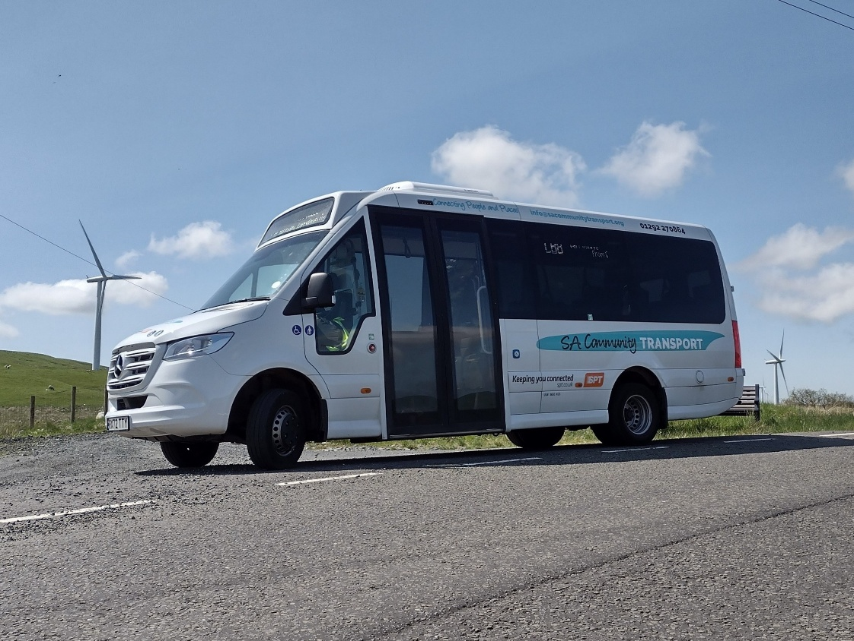



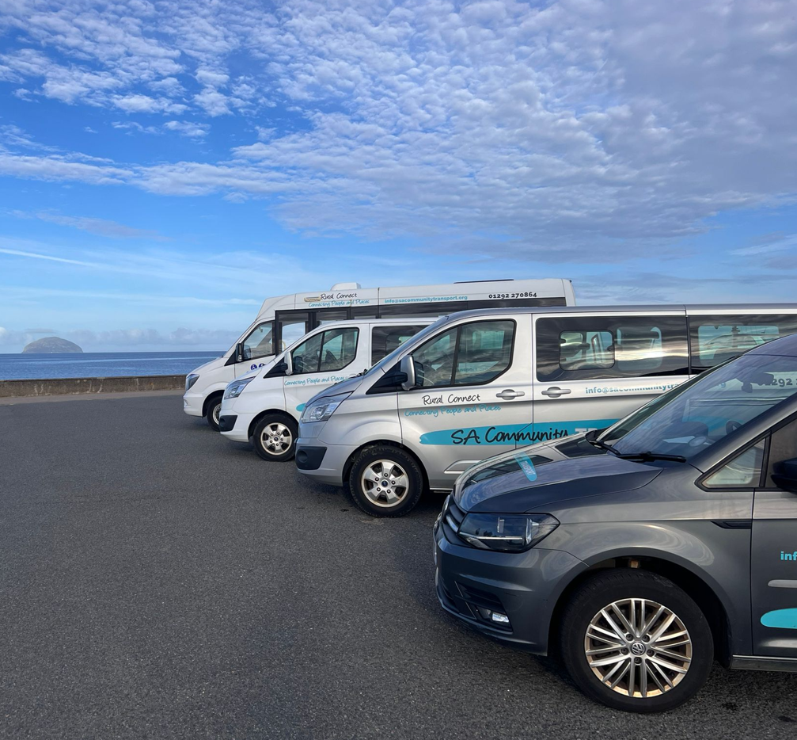
INFORMATION LEAFLET
29 Crown Street. Ayr. KA8 8AG.
01292 270864.

info@sacommunitytransport.org

www.sacommunitytransport.org

 South-Ayrshire-Community-Transport

CHARGES; FROM APRIL 2026

Booking Fee | £40
Mileage Fee | £0.95 per mile (All mileage is chargeable)
SACT Driver | £20 per hour
Group membership | Free of charge

AVAILABLE VEHICLES (seats incl. driver)

- 1 x 16 seat (2 x w/c accessible) VW Crafter (D1 Required)
- 1 x 15-seater Ford E Transit; no w/c access
- 1 x 16 seat Fiat Ducato E-Bus no w/c access
- 1 x 10-seater Maxus eDELIVER9
- 1 x 13-seater Maxus eDELIVER9
- 1 x 7-seater Nissan eN200 EV no w/c access
- 1 x 5-seater w/c accessible VW Vista
- 2 x 9-seater w/c accessible Ford Tourneo MPV
- 4 x 17-seater w/c accessible Boxer / Flexilite
- 2 x 17-seater w/c accessible Mercedes Sprinter (D1 Required)
- 2 x 17-seater Ford Transit; no w/c access (D1 Required)

Vehicles Available in Ayr, Maybole and Girvan

BOOKINGS CAN BE MADE BY:

- Email – info@sacommunitytransport.org
- Telephone: 01292 270864
- In Writing: SACT, 29 Crown Street, Ayr, KA8 8AG
- Download forms: Here - www.sacommunitytransport.org/sact-ayr-download-area/
DRIVER and TRAINING
- Charges are based on self-drive. SACT can provide a driver at an additional cost of £20.00 per hour (00:00 – 07:00 £30 per hour) or register your driver with SACT as a volunteer.
- Training: Drivers wishing to arrange MIDAS, PATS or D1 training should contact the office in the first instance, and we will be able to advise you. All drivers must have a D1 on their licences to be able to drive the heavier SACT Minibuses. Smaller MPVs and lightweight 17 seaters do not require a D1 under certain conditions.
- Familiarisation: Drivers wishing to arrange a bus familiarisation session, please contact us on 01292 270864
ADDITIONAL CHARGES
- Cleaning Charge (if necessary); £30.00 minimum
- Cancellation fees; 1-24hrs notice £35.00; less than 1hrs notice; £40.00; less than 1hr or on arrival with SACT Driver; £56
- Overnight Charge; £30 per Night
- All penalty charge notices for parking, speeding, LEZ, ULEZ or any other matter are the responsibility of the driver and their organisation. SACT will pass on the drivers details to the relevant authorities in the event of not being notified of any infringements.
OUT & ABOUT CLUB
- SACT arranges trips to garden centres, shopping centres, restaurants and other popular attractions.
- For further information please contact SACT on 01292 270864, email info@sacommunitytransport.org or visit the website at www.sacommunitytransport.org

THE LAW
- SACT operates a 4 days per week ticketed scheduled service between Barr and Girvan under a Section 22 permit.
- The rest of the time, SACT operates this and its other minibuses/MPVs under Section 19 permits under the relevant Road Traffic Act which allows the charging of passengers to cover costs, providing the passengers are members of affiliated groups or are being helped by the affiliated group as an aspect of social, welfare or cultural community service.
- No other use is permitted under this legislation.
The bus cannot be hired by individuals for what is considered “commercial work” e.g. weddings, birthdays etc. Further details can be obtained by contacting SACT.

Full Terms and Conditions available on our booking forms and online.

